Lab Exercise 4
Chapter 4

Programming Exercises

16. Write a program that accepts the number of bags sold and the unit weight of a bag of coffee in pounds (lb) and displays the total price of the sale, computed as

Sub Total Price = Weight of a Bag x Number of Bags x Price Per Pound.
Total Price = Sub Total Price + Sub Total Price x Tax Rate.

Display the result in the following manner:
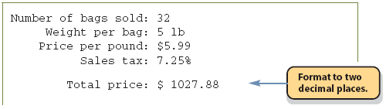

Define and create a programmer-defined CoffeeBag class. Include class constants for the price per pound and tax rate with the values $5.99 per pound and 7.25 percent, respectively. Use the UML class diagram in Figure 1 and the main class in Figure 2 as a guidance to create the CoffeeBag class.

Tips: Class Descriptions

CoffeeBag
A class that contains the number of bags sold and the size of the bags. This class also knows how much a bag of coffee costs and the sales tax and computes the totals for the sale. Use the constructor to set the unit weight and number of units.

Method | Visibility | Purpose
setUnitWeight | public | Set the weight for the bags
setNumberOfUnits | public | Set the number of units desired for the order
getUnitWeight | public | Get the weight for the bags
getNumberOfUnits | public | Get the number of units ordered
getPricePerPound | public | Get the price per pound of coffee
getSalesTax | public | Get the sales tax percentage
getSubtotal | public | Get the price of the order without tax
getTotalPrice | public | Get the price of the order including tax

CoffeeShipper
The main control class of the application. This class takes input from the user and displays the output after all calculations have been completed. This class contains only the main() method.

Tips: Class diagram for this exercises

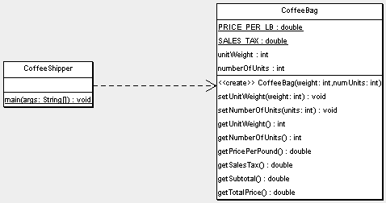

Figure 1

import javax.swing.*;
import java.text.*;
public class CoffeeShipper {

public static void main(String[] args) {

CoffeeBag coffeeBag;
int numUnits, unitWeight;
String input;

//Get input
input = JOptionPane.showInputDialog(null, "Number of Bags sold:");
numUnits = Integer.parseInt(input);

input = JOptionPane.showInputDialog(null, "Weight of a bag (in lbs, e.g. 5):");
unitWeight = Integer.parseInt(input);

coffeeBag = new CoffeeBag(unitWeight, numUnits);
DecimalFormat df = new DecimalFormat("0.00");

//Display the result
System.out.println("Number of bags sold: " +
coffeeBag.getNumberOfUnits());
System.out.println(" Weight per bag: " +
coffeeBag.getUnitWeight() + “ lb”);
System.out.println(" Price per pound: $" +
coffeeBag.getPricePerPound());
System.out.println(" Sales tax: " +
df.format(coffeeBag.getSalesTax()) + "%");
System.out.println("\n");
System.out.println(" Total price: $ " +
df.format(coffeeBag.getTotalPrice()) );
System.out.println("\n");
}

}

Figure 2: Main Class

20. Create a new JFrame Form name CarLoanForm as the Graphical User Interface for this application (Refer Figure 3). Based on the equation given in Figure 4 and the source code for CarLoanForm in Figure 5, create a class name CarLoan to calculate the Balance, Total Interest, Total Balance and Payment Per Month. First the user must enter the Car Price, Interest Rate, Instalment and the car loan Years. When the user clicks the Calculate Button, the application will calculate the Balance, Total Interest, Total Balance and Payment Per Month. Draw the UML class diagram for CarLoan.
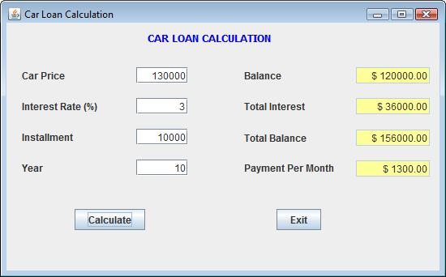

Figure 3

- Balance = Car Price – Installment
- Total Interest = Balance x Interest Rate x Year
- Total Balance = Balance + Total Interest
- Payment Per Month = Total Balance ÷ Year ÷ 12

Figure 4

import java.text.*;

//Code for CarLoanForm Constructor
{ initComponents();
setTitle ( "Car Loan Calculation" );
setLocation(150,150);
}

//Code for Exit Button
{ System.exit(0);
}

//Code for Calculate Button
{
DecimalFormat df = new DecimalFormat("0.00");

CarLoan carLoan1;
carLoan1 = new CarLoan();

double price,interest,installment,year;

price = Double.parseDouble(jTextField1.getText());
interest = Double.parseDouble(jTextField2.getText());
installment = Double.parseDouble(jTextField3.getText());
year = Double.parseDouble(jTextField4.getText());

carLoan1.setCarPrice(price);
carLoan1.setInterestRate(interest);
carLoan1.setInstallment(installment);
carLoan1.setYear(year);

jTextField5.setText("$ "+String.valueOf(df.format(carLoan1.getBalance())));
jTextField6.setText("$ "+String.valueOf(df.format(carLoan1.getTotalInterest())));
jTextField7.setText("$ "+String.valueOf(df.format(carLoan1.getTotalBalance())));
jTextField8.setText("$ "+String.valueOf(df.format(carLoan1.getPaymentPerMonth())));
}

Figure 5

